Python实验报告8

学号：117060400212 姓名：张佳奇 班级：应用统计学2班

指导老师:林卫中

实验名称：unit6 exercise及一些其他习题

实验要求：介绍了组合数据类型中元组、数组、列表和字典等类型及基本操作还有之前未完成的习题

实验题目1：

七段数码管

算法实现：

1：# 7段数码管

import turtle, datetime

strcol = ['red','blue','yellow','gold','violet','purple','green','darkgreen','grey','orange']

def drawGap(): #绘制数码管间隔

turtle.penup()

turtle.fd(5)

def drawLine(draw):#绘制单段数码管

drawGap()

turtle.pendown() if draw else turtle.penup()

turtle.fd(40)

drawGap()

turtle.right(90)

def drawDigit(digit): #根据数字绘制七段数码管

turtle.pencolor(strcol[digit])

drawLine(True) if digit in [2,3,4,5,6,8,9] else drawLine(False)

drawLine(True) if digit in [0,1,3,4,5,6,7,8,9] else drawLine(False)

drawLine(True) if digit in [0,2,3,5,6,8,9] else drawLine(False)

drawLine(True) if digit in [0,2,6,8] else drawLine(False)

turtle.left(90)

drawLine(True) if digit in [0,4,5,6,8,9] else drawLine(False)

drawLine(True) if digit in [0,2,3,5,6,7,8,9] else drawLine(False)

drawLine(True) if digit in [0,1,2,3,4,7,8,9] else drawLine(False)

turtle.left(180)

turtle.penup()

turtle.fd(20)

def drawDate(date): #获得要输出的数字

for i in date:

if i == '-':

turtle.pencolor("black")

turtle.write('年',font=("Arial", 18, "normal"))

turtle.fd(40)

elif i == '=':

turtle.pencolor("black")

turtle.write('月',font=("Arial", 18, "normal"))

turtle.fd(40)

elif i == '+':

turtle.pencolor("black")

turtle.write('日',font=("Arial", 18, "normal"))

else:

drawDigit(eval(i))

def main():

turtle.setup(800, 350, 200, 200)

turtle.colormode(255)

turtle.penup()

turtle.fd(-300)

turtle.pensize(5)

drawDate(datetime.datetime.now().strftime('%Y-%m=%d+'))

turtle.hideturtle()

turtle.done()

main()

2：

import turtle, datetime

def drawGap(): #绘制数码管间隔

turtle.penup()

turtle.fd(5)

def drawLine(draw):#绘制单段数码管

drawGap()

turtle.pendown() if draw else turtle.penup()

turtle.fd(40)

drawGap()

turtle.right(90)

def drawDigit(digit): #根据数字绘制七段数码管

turtle.pencolor(strcol[0])

drawLine(True) if digit in [2,3,4,5,6,8,9] else drawLine(False)

turtle.pencolor(strcol[1])

drawLine(True) if digit in [0,1,3,4,5,6,7,8,9] else drawLine(False)

turtle.pencolor(strcol[2])

drawLine(True) if digit in [0,2,3,5,6,8,9] else drawLine(False)

turtle.pencolor(strcol[3])

drawLine(True) if digit in [0,2,6,8] else drawLine(False)

turtle.pencolor(strcol[4])

turtle.left(90)

drawLine(True) if digit in [0,4,5,6,8,9] else drawLine(False)

turtle.pencolor(strcol[5])

drawLine(True) if digit in [0,2,3,5,6,7,8,9] else drawLine(False)

turtle.pencolor(strcol[6])

drawLine(True) if digit in [0,1,2,3,4,7,8,9] else drawLine(False)

turtle.left(180)

turtle.penup()

turtle.fd(20)

def drawDate(date): #获得要输出的数字

for i in date:

if i == '-':

turtle.pencolor("black")

turtle.write('年',font=("Arial", 18, "normal"))

turtle.fd(40)

elif i == '=':

turtle.pencolor("black")

turtle.write('月',font=("Arial", 18, "normal"))

turtle.fd(40)

elif i == '+':

turtle.pencolor("black")

turtle.write('日',font=("Arial", 18, "normal"))

else:

drawDigit(eval(i))

def main():

turtle.setup(800, 350, 200, 200)

turtle.colormode(255)

turtle.penup()

turtle.fd(-300)

turtle.pensize(5)

drawDate(datetime.datetime.now().strftime('%Y-%m=%d+'))

turtle.hideturtle()

turtle.done()

main()

3：

import turtle, datetime,random

def drawGap(): #绘制数码管间隔

turtle.penup()

turtle.fd(5)

def drawLine(draw):#绘制单段数码管

drawGap()

r = random.randint(0,255)

g = random.randint(0,255)

b = random.randint(0,255)

turtle.pencolor((r,g,b))

turtle.pendown() if draw else turtle.penup()

turtle.fd(40)

drawGap()

turtle.right(90)

def drawDigit(digit): #根据数字绘制七段数码管

drawLine(True) if digit in [2,3,4,5,6,8,9] else drawLine(False)

drawLine(True) if digit in [0,1,3,4,5,6,7,8,9] else drawLine(False)

drawLine(True) if digit in [0,2,3,5,6,8,9] else drawLine(False)

drawLine(True) if digit in [0,2,6,8] else drawLine(False)

turtle.left(90)

drawLine(True) if digit in [0,4,5,6,8,9] else drawLine(False)

drawLine(True) if digit in [0,2,3,5,6,7,8,9] else drawLine(False)

drawLine(True) if digit in [0,1,2,3,4,7,8,9] else drawLine(False)

turtle.left(180)

turtle.penup()

turtle.fd(20)

def drawDate(date): #获得要输出的数字

for i in date:

if i == '-':

turtle.pencolor("black")

turtle.write('年',font=("Arial", 18, "normal"))

turtle.fd(40)

elif i == '=':

turtle.pencolor("black")

turtle.write('月',font=("Arial", 18, "normal"))

turtle.fd(40)

elif i == '+':

turtle.pencolor("black")

turtle.write('日',font=("Arial", 18, "normal"))

else:

drawDigit(eval(i))

def main():

turtle.setup(800, 350, 200, 200)

turtle.colormode(255)

turtle.penup()

turtle.fd(-300)

turtle.pensize(5)

drawDate(datetime.datetime.now().strftime('%Y-%m=%d+'))

turtle.hideturtle()

turtle.done()

main()

实验结果：

1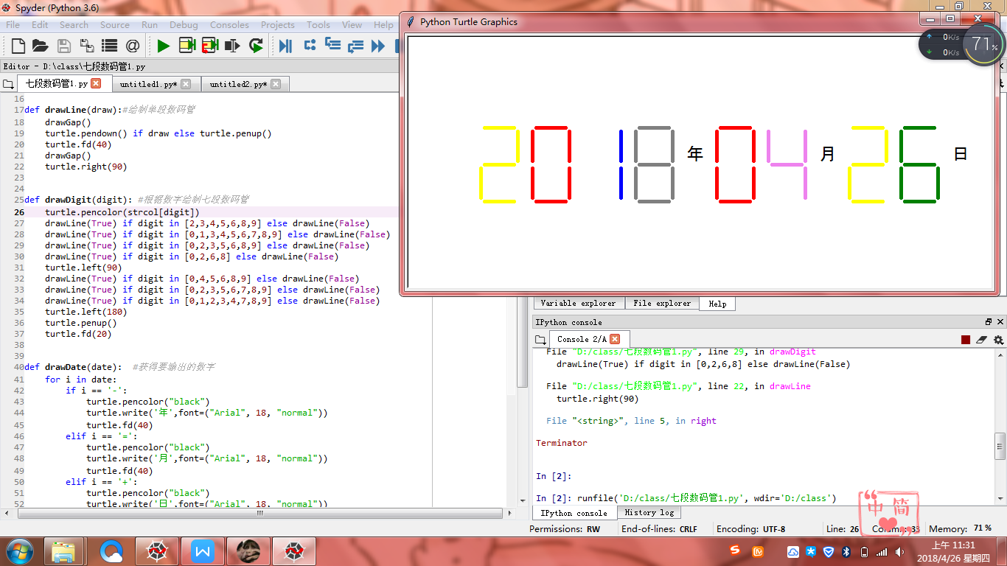

2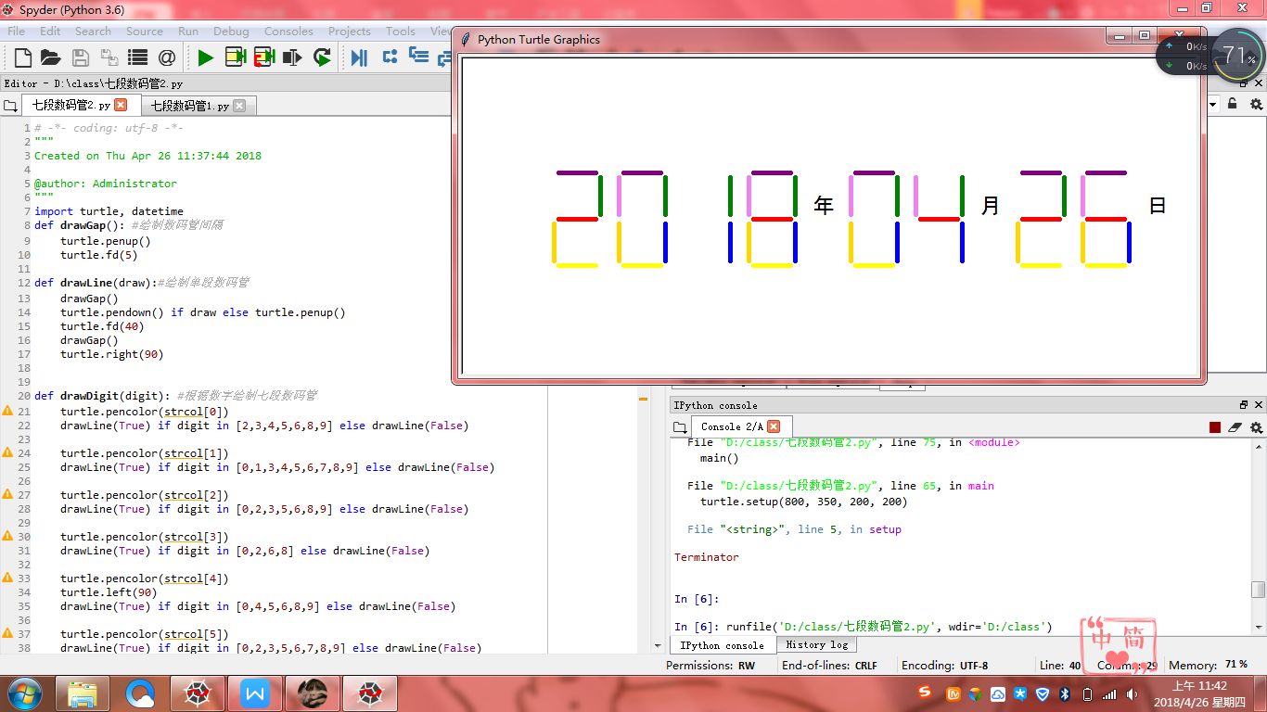

3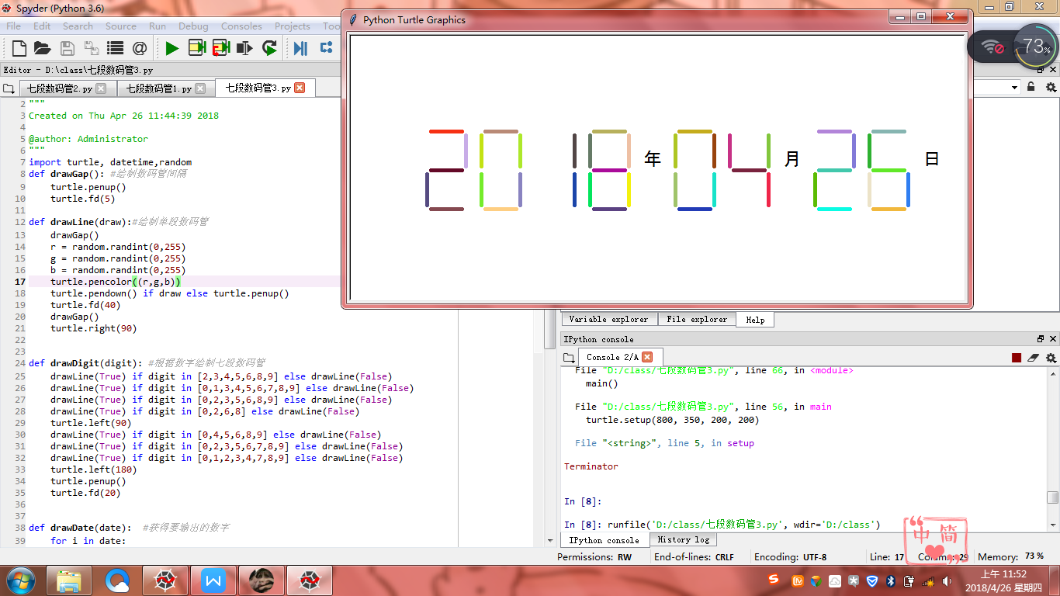

实验题目2：

Ex6.1 随机密码生成

算法实现：

import random

ch = []

c = 'A'

while c <= 'Z' :

ch.append(c)

c = chr(ord(c) + 1)

c = 'a'

while c <= 'z' :

ch.append(c)

c = chr(ord(c) + 1)

c = '1'

while c<= '9' :

ch.append(c)

c = chr(ord(c) + 1)

def generatePSW(chList:list,n=8):

psw = []

size = len(chList)

for i in range(n):

k = random.randint(0,size-1)

psw.append( chList[k])

return "".join(psw)

for i in range(10):

print("第{0:2}个随机密码: {1}".format(i+1,generatePSW(ch)))

实验结果：

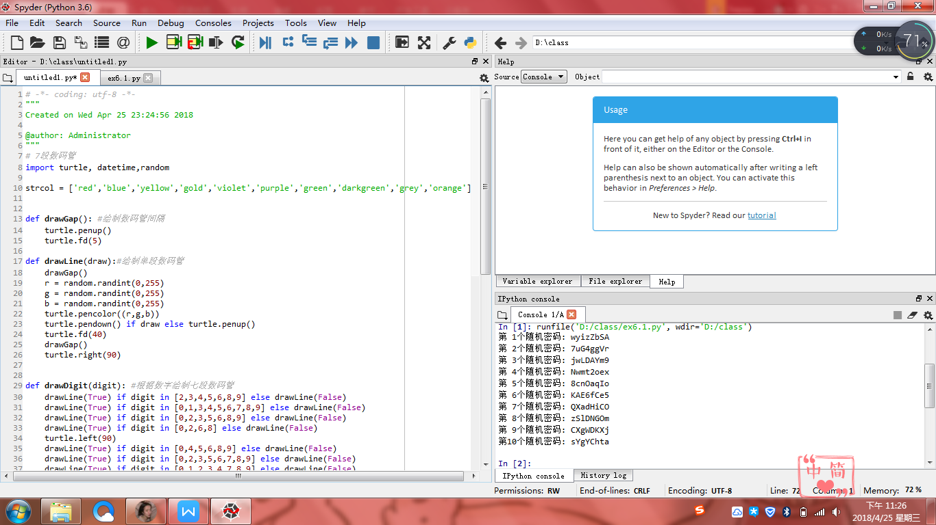

实验题目3：

Ex6.2 重复元素判定

算法实现：

def isRepetitive(ls):

for x in ls:

if ls.count(x) > 1:

return True

return False

list1 = [1,2,1,3,1]

if isRepetitive(list1):

print("有重复元素")

else:

print("没有重复元素")

list2 = ['china','chinese']

if isRepetitive(list2):

print("有重复元素")

else:

print("没有重复元素")

实验结果：

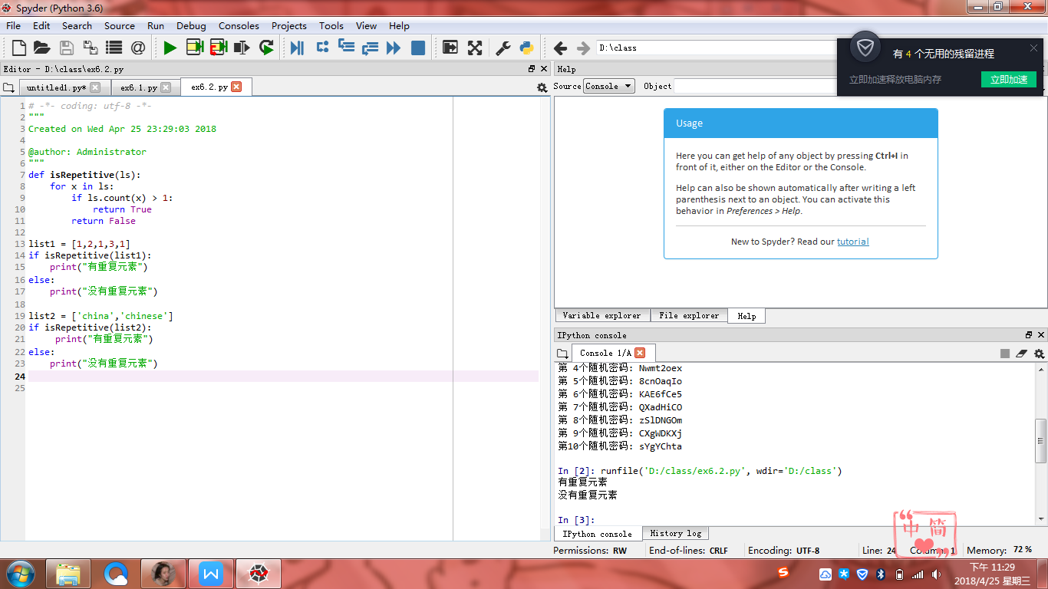

实验题目4：

Ex6.3 重复元素判定续

算法实现：

def isRepetitive2(ls):

nest = set(ls)

if len(nest)<len(ls):

return True

return False

list1 = [1,2,1,3,1]

if isRepetitive2(list1):

print("有重复元素")

else:

print("没有重复元素")

list2 = ['china','chinese']

if isRepetitive2(list2):

print("有重复元素")

else:

print("没有重复元素")

实验结果：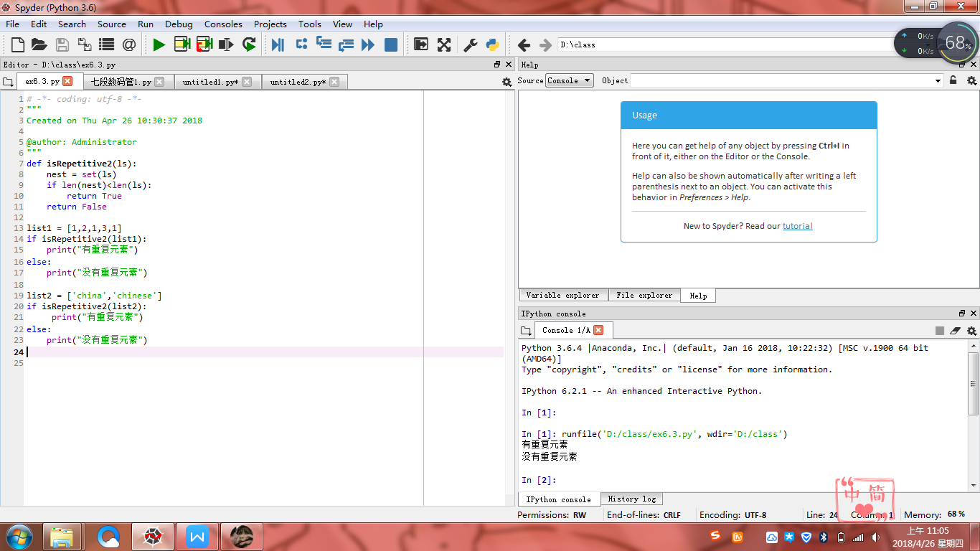

小结：感觉这节课的效率不是很高，做不到举一反三，学的太死板。感觉还是有些难。。。。嗯，还要加油，课下多做些练习吧！在做七段数码管的时候，不够细心，忘记引入库，还是基础不够扎实吧，还要努力努力在努力呢!!